

**Draft (May 2021)**

**International Water Management Institute**

**New Delhi**

Drought Proofing Assessment:

Cherukuru watershed, Prakasam, Andhra Pradesh

Contents

1 Cherukuru watershed 3

1.1 Land Use & Soil 3

1.2 Cropping pattern 4

1.3 Irrigation & Domestic 4

2 Drought risk assessment 5

3 Drought proofing assessment 7

4 Application of drought proofing tool 8

4.1 Baseline scenario 9

4.1.1 Water balance 9

4.1.2 Crop water requirement and irrigation water requirement 10

4.1.3 Crop water requirement met and crop yield 10

4.1.4 Drought proofing and Quadrant 11

5 Plan water management interventions 12

5.1 Water management interventions scenarios 13

5.2 Interventions impact on mild drought 14

5.3 Interventions impact on moderate drought 17

5 Cost and benefit analysis 20

6 Conclusion and recommendation 21

Appendix A: Input data 23

# **Cherukuru watershed**

Cherukuru watershed is located in the Ponnaluru block of Prakasam District in Andhra Pradesh, India (Figure 1a). The Watershed is part of the Paleru river basin. Total area of the watershed is 6727 hectares (ha). Watershed receives rainfall from both southwest and northeast monsoon with an average annual rainfall of 869 mm (1980-2017). Of the annual rainfall, ~ 47 % is received during the southwest monsoon (June – September) and 40 % during the northeast monsoon (Oct-Dec) (Figure 1b). October is the wettest month of the year. The average annual mean temperature is 28.8 ᵒC with minimum temperature observed in December with a mean of 24.5 ᵒC and maximum temperature is observed in May with a mean of 33.7 ᵒC (Srivastava et al., 2009).

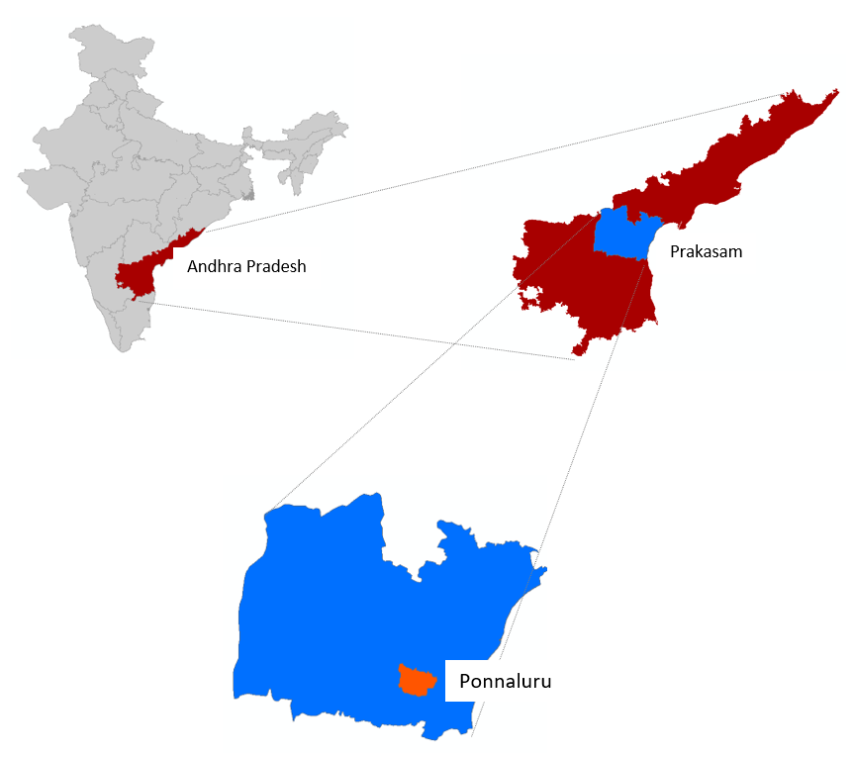

Figure 1 a) Study area map and b) Mean monthly rainfall and temperature of Cherukuru

## 

## **Land Use & Soil**

Watershed is predominantly cultivated with agricultural area occupying ~ 70 % of the watershed area (Table 1) followed by built up, pasture, and forest areas. Clay soil is the predominant soil type in the watershed covering 60 % of the area followed by clayey loam and sandy loam.

Table 1: Land use details of Kulans catchment

|  |  |  |
| --- | --- | --- |
| S.no | Description | Area (ha) |
| Total Agri catchment Area (ha) | | 6727 |
|  | Agriculture Area (Net cultivated sown area) | 4708 |
|  | Fallow | 350 |
|  | Built-up / Settlements | 468 |
|  | Waterbodies | 350 |
|  | Pasture | 425 |
|  | Forest | 426 |

## **Cropping pattern**

The major crop grown in the watershed is Tobacco, followed by long-duration Chilly. Tobacco is sown near the end of the southwest monsoon in September. Chilly is sown in August and taken as long duration crop (210 days). Short duration Bengal gram (60 days) is taken during the northeast monsoon. Tobacco and Bengal gram are primarily taken as rainfed crops with provision for supplemental irrigation if necessary. Chilly is completely irrigated. Other than there are Eucalyptus plantations and a small area under horticulture crops (papaya, guava).

|  |  |  |  |  |  |  |  |  |  |  |  |
| --- | --- | --- | --- | --- | --- | --- | --- | --- | --- | --- | --- |
| **Aug** | **Sep** | **Oct** | **Nov** | **Dec** | **Jan** | **Feb** | **Mar** | **Apr** | **May** | **June** | **July** |

Tobacco

Bengal gram

Chilly

**Figure 2: Cropping calendar of watershed**

## **Irrigation & Domestic**

Of the total net cropped area under crops (3742 ha), 60 % is partially or fully equipped with irrigation. Surface water (~ 71 %) through tanks (~ 53 %) and small reservoirs (18 %) is the main source of irrigation in the district followed by groundwater irrigation from deep tube wells (29 %). Groundwater extraction in the Prakasam district and Ponnaluru block is moderate but the overall stage is classified as safe with the stage of extraction (total abstraction/total recharge) at ~ 42 % (CGWB, 2019). Groundwater primarily in the watershed occurs under crystalline aquifer, granite-gneiss lacking primary porosity, and availability depends on the thickness of the weathered zone available and degree of fracturing/jointing. Dug wells are mostly defunct in the watershed as groundwater levels are more than 10 m throughout the year and deep tube wells are used for irrigation. Pre-monsoon groundwater levels range from 15-17 m and post-monsoon groundwater levels range from 10-12 m.

# **Drought risk assessment**

For assessing ITC agri-catchments, the widely used rainfall index ‘*Standard Precipitation Index’ (SPI) (*World Bank, 2019; Sönmez et al., 2005) is used. SPI is calculated by taking the difference of the precipitation from the mean for a particular time step, and then dividing it by the standard deviation and is based on the long-term precipitation data (Sönmez et al., 2005). For SPI, only rainfall data is needed which is the primary causative factor of drought thus making SPI easy to calculate.



SPI is a dimensionless index where negative values indicate drought and positive values wet conditions with a range of SPI values can be categorized across different intensities (Table 2).

Table 2: SPI values-based drought categories

|  |  |
| --- | --- |
| **SPI values** | **Drought category** |
| **0 to -0.99** | Mild drought |
| **-1.00 to -1.49** | Moderate drought |
| **-1.50 to -1.99** | Severe drought |
| **< -2.0** | Extreme drought |

SPI is calculated based on monthly rainfall data of the last 38 years (1980-2017). To segregate seasonal and annual drought, drought frequency for the South West (June-Sep) and North East monsoon (Oct-Nov) is calculated separately. Shorter periods (seasonal droughts) are important to assess agricultural droughts whereas longer/annual droughts are used to assess hydrological droughts. Based on an assessment of seasonal and annual droughts, effective planning and designing of interventions to mitigate drought can be done.

Based on seasonal and annual rainfall assessment, % of years under different drought categories is calculated (**Table 3**). For more than 50 % of the years, there is no drought. Results show that mild drought is the most occurring drought in the regions occurring every third year for both South West and North East monsoon seasons. After that, moderate drought has the highest frequency of occurring, but the relative frequency is low. The occurrence of severe and extreme drought is very limited. Annual drought occurrent is different showing the impact of calculating drought frequency for different periods. Annual mild, moderate, and severe droughts occur more or less at the same frequency. The annual time series of rainfall with drought category (Figure 3) shows that though most years have been normal, drought keeps recurring frequently. The last 3 years have seen 2 severe and 1 moderate drought. This suggests that drought proofing activities should actively focus on covering mild, moderate, and severe droughts.

**Table 3:** **Drought intensity and their frequency for different periods.** The percentage indicates the percent of total assessed years classified under different drought categories.

|  |  |  |  |
| --- | --- | --- | --- |
|  | **South West (June-Sep)** | **North East (Oct-Nov)** | **Annual** |
| **No drought** | 53% | 50% | 61% |
| **Mild drought** | 37% | 34% | 18% |
| **Moderate drought** | 8% | 11% | 11% |
| **Severe drought** | 0% | 3% | 11% |
| **Extreme drought** | 3% | 3% | 0% |

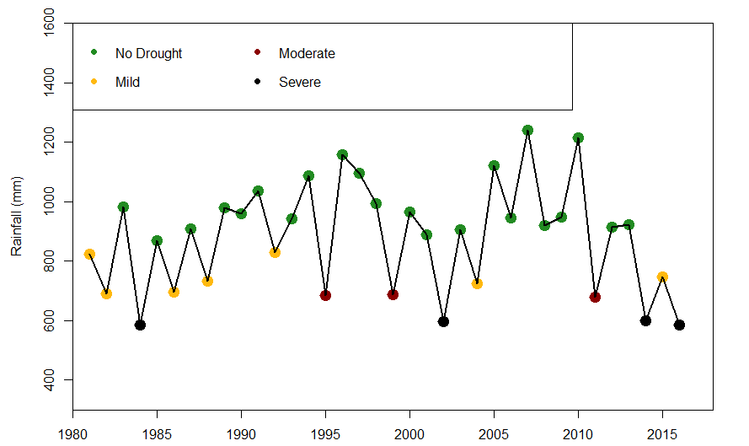

Figure 3: Annual time series of rainfall with drought category

# **Drought proofing assessment**

Drought proofing assessment is carried out using the developed conceptual drought proofing framework (**Figure 4**). In the framework, Drought proofing in a watershed is conceptualized as an interaction between water availability for crops and water use efficiency (Figure 4). At the base level, drought proofing is defined as an interaction between water availability for a crop (mm or m3 ha-1 or % of crop water needs met) and water use efficiency (Figure 4). Water availability for a crop is the water available from all the sources (rainfall, soil moisture, groundwater, and surface water storage) to meet crop water requirements. Water efficiency determines how efficiently irrigation water is used. For irrigated areas, this is the irrigation application efficiency. For rainfed areas, this can be translated to how efficiently rainfall is used.

Across a simple 2*2 plane, we can identify four distinct quadrants (**Figure 4**) with water availability for a crop on the y-axis and crop water use efficiency (WUE) on x-axis. Based on the analysis and where watershed crops lie in different rainfall years, users can identify the type and intensity of required interventions. Water availability can be increased with supply augmenting practices (storage, recharge, and soil moisture conservation) whereas water use efficiency can be increased through water saving and irrigation application efficiency measures (micro-irrigation).

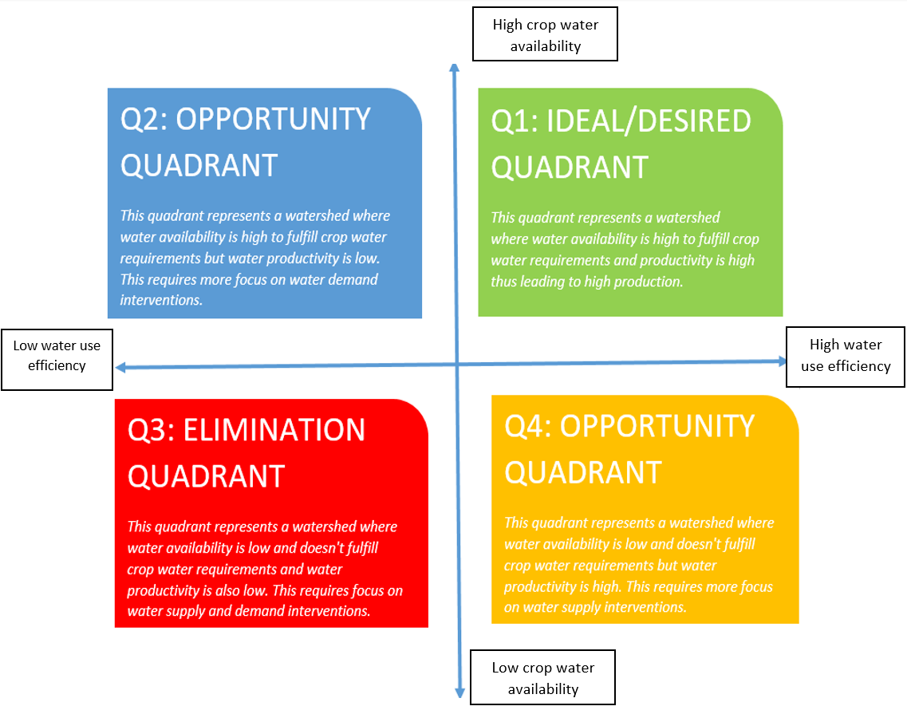

**Figure 4: Conceptual physical drought proofing framework**

With water as the key input to the drought-proofing framework (**Figure 4**), water balance tool is developed to operationalize the framework. The tool is modeled in excel spreadsheet with minimum input data requirements for simplifications. Drought Proofing Tool is developed in MS Excel + Visual Basic Editor (VBA) platform.

The water balance tool helps in site-specific water balance, crop yield, and crop requirement assessments. The two-key function of the tool is as follows:

* To assess the water balance of the study area for various hydrological conditions (dry, normal & wet years)
* To assess the impact of proposed water management interventions in achieving drought proofing

Here we provide the results of the application of the water balance tool for the watershed. For details on the methodological and workflow of the tool, please check Technical Manual, User Manual, and Case Study example.

# **Application of water balance tool**

The first step is the entry of input data. Input data to tool covers: Land use and soil data, crop details, irrigation and domestic and rainfall and temperature (see user manual). While a brief of each is provided in the study area description and summarised in Table 4, and detailed input data is given in Appendix A.

**Table 4:** **Overview of input data.** Detailed input data is given in Appendix A

|  |  |
| --- | --- |
| Parameter | Information |
| Land use | Table 1 |
| Soil | Clay (70 %) , Clay loam (30 %) |
| Crops | Kharif: Tobacco |
| Rabi: Bengal gram |
| Kharif (long): Chilly |
| Irrigation | Crop wise irrigated area, Surface water irrigation 70 %, default irrigation efficiency of 0.4 |
| Rainfall and temperature | Daily rainfall, mean, max and min temperature data (20 years) |

The flow diagram (**Figure 5**) below gives the steps involved in running the tool and planning water management interventions.

* Step1: Input data is entered in the tool. See Appendix A and the user manual.
* Step 2: Baseline scenario is simulated. Baseline scenario is where no water management interventions are in place.
* Step 3: Water balance, crop water requirements, and crop water deficit results are analyzed
* Step 4: Based on analyzed results, water management interventions are planned and entered in the tool as scenarios
* Step 5: Scenarios are simulated and their impact on drought proofing is analyzed. If drought proofing is not realized, step 3 and 4 are repeated until the best results on drought proofing are obtained.

Accordingly, results in the upcoming section are given in the same order. As mild and moderate droughts are most frequent, drought proofing assessment is carried out for the same.

**Figure 5: Conceptual workflow of applying drought proofing tool**

### **Baseline scenario**

### **Water balance**

**Table** 5 gives the water balance results for the watershed for the normal, mild, and moderate drought years. Normal years include all years where rainfall is above the drought threshold, including wet years. The rainfall in mild and moderate years is lesser by 26 % and 41 % relative to normal years. In normal, runoff (26.8 % of rainfall) is high but decreasing markedly in mild (9.1 % of rainfall) and moderate drought years (6.3 % of rainfall). Recharge is more consistent and ranges from 7-10 % of rainfall, again increasing from moderate drought to normal years.

Table 5: Water balance results (in mm)

|  |  |  |  |  |
| --- | --- | --- | --- | --- |
| **Year** | **Rainfall** | **Runoff** | **recharge** | **ET** |
| Normal | 1041.9 | 1041.9 | 279.1 | 100.9 |
| Mild | 773.1 | 773.1 | 70.0 | 58.6 |
| Moderate | 616.7 | 616.7 | 38.8 | 42.8 |

### **Crop water requirement and irrigation water requirement**

Table 6 gives the crop water requirement (CWR) and irrigation water requirement (IWR) of each simulated crop for normal, mild, and moderate drought years. CWR of the crop is calculated based on reference evapotranspiration (ETo). As there is a slight temperature difference between drought years, CWR differs among different drought years.

High CWR is for chilly (800-820 mm) as it is taken as a long duration (210 days) crop. Bengal gram which is taken as a short duration (60 days) crop has very low CWR (~ 200 mm). Tobacco is the main Kharif crop with moderate CWR (~450 mm). Irrigation water requirement (IWR) is the difference between CWR and rainfall in the crop growing period. As only Tobacco (partially) and Chilly are irrigated in the watershed (Appendix A, Table 1b), IWR for them is estimated. IWR for chilly is very high, more than 30 % of total CWR, as chilly is long duration crop with harvest in late February covering post-monsoon period when rainfall is limited and crop completely on residual soil moisture and irrigation. Relatively, IWR for Tobacco is low and but increases from normal to moderate where IWR is almost 36 % of CWR.

Table 6: CWR & IWR of the crops in the watershed (in mm)

|  |  |  |  |  |  |  |  |
| --- | --- | --- | --- | --- | --- | --- | --- |
| Season | Crop | Normal | | Mild | | Moderate | |
| **CWR** | **IWR** | **CWR** | **IWR** | **CWR** | **IWR** |
| Kharif | **Tobacco** | 444.9 | 89.9 | 454.9 | 110.1 | 465.0 | 170.2 |
| Rabi | **Bengal Gram** | 196.3 | - | 198.9 | - | 204.1 | - |
| Long (Kharif) | **Chilly** | 801.7 | 299.7 | 818.7 | 373.9 | 823.2 | 446.6 |

### **Crop water requirement met and crop yield**

CWR is met by rainfall and soil moisture in the case of rainfed crops whereas irrigated areas can also access irrigation storage to meet CWR.  Results show that for normal years, most of CWR is met for irrigated crops (chilly and Tobacco) (~ 99 %) and even for rainfed crops, CWR met is high (> 80 %) with the lowest being the case for rainfed Tobacco (80 %). This is expected in normal years as rainfall is high. Even in mild and moderate drought years, the impact on irrigated crops is limited with CWR being mostly met (> 80 %). However, CWR met decreases from more than > 98 % CWR met in normal years to ~ 80 %. This reflects that irrigation storage is sufficient to meet much of the irrigation demand of crops.

However, this is not the case for the rainfed Tobacco crop. For rainfed Tobacco, CWR met decreases from 80 % in normal years to 64 % in moderate drought years. This reflects the need for building supplemental irrigation facilities for Tobacco in conjunction with developing supply measures to support irrigation. Bengal gram is also rainfed but doesn’t get severely impacted by drought. This is because it has low CWR as it is taken as short duration crop (60 days). Even in moderate drought years, up to 80 % of CWR is met.

Table 7: Percent of total CWR met for each crop in different drought years

|  |  |  |  |  |  |  |  |
| --- | --- | --- | --- | --- | --- | --- | --- |
| Season | Crop | Normal | | Mild | | Moderate | |
| **Irrigated** | **rainfed** | **Irrigated** | **rainfed** | **Irrigated** | **rainfed** |
| Kharif | **Tobacco** | 99.9% | 79.9% | 94.0% | 75.8% | 89.2% | 63.5% |
| Rabi | **Bengal Gram** | - | 86.6% | - | 83.0% | - | 79.3% |
| Long (Kharif) | **Chilly** | 98.3% | - | 86.4% | - | 81.9% | - |

Crop yield (as % of attainable yield) is influenced by how much CWR is met (Table 7) and how sensitive it is to water deficits (Steduto et al., 2012). Crop yields (Table 8) follow the same trend as CWR met in Table 7. Crop yield of rainfed Tobacco is significantly impacted in drought years whereas impact is limited for irrigated crops with yield still more than > 80 % of attainable yields. This shows that interventions should primarily focus on increasing the CWR met for rainfed tobacco crops.

Table 8: Crop yield (as % of attainable yield) in different drought years

|  |  |  |  |  |  |  |  |
| --- | --- | --- | --- | --- | --- | --- | --- |
| Season | Crop | Normal | | Mild | | Moderate | |
| **Irrigated** | **rainfed** | **Irrigated** | **rainfed** | **Irrigated** | **rainfed** |
| Kharif | **Tobacco** | 99.9% | 81.9% | 94.6% | 78.3% | 90.2% | 67.1% |
| Rabi | **Bengal Gram** | - | 89.3% | - | 86.4% | - | 83.5% |
| Long (Kharif) | **Chilly** | 98.3% | - | 86.4% | - | 81.9% | - |

### **Drought proofing and Quadrant**

Plotting CWR met and irrigation efficiency of the crop on drought proofing quadrant (**Figure 6**) shows which crop and what kind of interventions are needed. As discussed above, it becomes clearer from drought proofing quadrant figures that additional interventions are mainly required for rainfed Tobacco crop as CWR met is low for moderate years. However, with all crops showing CWR met of ~ 80 % and low irrigation efficiency, there is a need to implement both supply and demand to improve both the CWR met and irrigation efficiency.

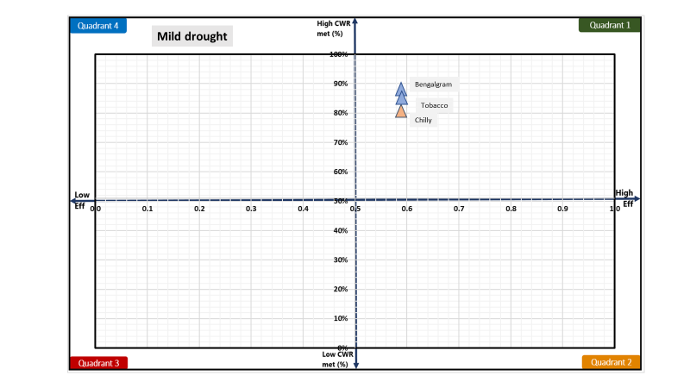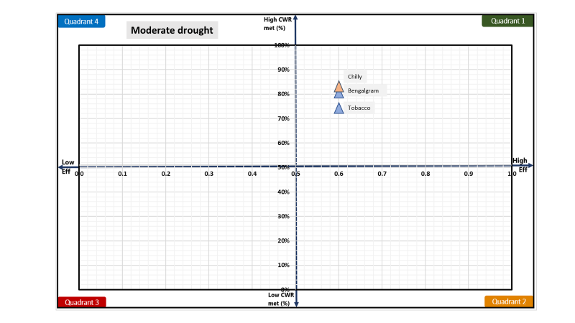

**Figure 6: Drought quadrant for mild (left) and moderate (right) drought**

# **Plan water management interventions**

Crop water balance and deficit (CWR met) shows which crops are impacted the most and drought-proofing quadrant shows which interventions are needed. However, the intensity or scale of water management interventions should be planned based on how much water is available and absolute crop deficits (in m3). Crop water deficits (CWR – CWR met) can be assessed from results on CWR (Table 6) and CWR met (Table 7). Table 9 gives the crop water deficit (in m3) for all crops for mild and moderate drought years. Crop water deficit (in m3) is derived by multiplying unmet CWR (in mm) to the crop area.

Results show that the highest absolute water deficit is for Tobacco (averaging rainfed and irrigated area) followed by chilly for both mild and moderate drought years. This is driven by high IWR and low CWR met (%) as given in Table 7. Absolute crop water deficit (in m3) can give an idea of intensity of interventions to plan. In addition to supply measures, water-saving can be achieved through improving irrigation efficiency measures. Table 9 also gives the potential savings that can be achieved if irrigation efficiency is improved to 0.75 and 0.9 for all crops. Potential savings (in m3) are derived assuming all irrigation water requirement (IWR) is met through increased efficiency. Calculations show that savings from increased irrigation efficiency can potentially cover 40-75 % of absolute crop water deficits.

Table 9: Absolute crop water deficit and potential saving from increasing irrigation efficiency for mild and moderate drought years.

|  |  |  |  |  |  |  |  |
| --- | --- | --- | --- | --- | --- | --- | --- |
| **Season** | **Crop** | **Mild** | | | **Moderate** | | |
| **Deficit (‘000 m3)a** | **Potential savings (‘000 m3)b** | | **Deficit (‘000 m3)** | **Potential savings (‘000 m3)** | |
|  | Eff =0.75 | Eff = 0.9 |  | Eff = 0.75 | Eff = 0.9 |
| Kharif | | **Tobacco** | 1289 | 323 | 538 | 2070 | 499 | 832 |
| Rabi | | **Bengal Gram** | 388 | - | - | 485 | - | - |
| Long (Kharif) | | **Chilly** | 790 | 711 | 1479 | 1061 | 1060 | 1767 |
|  | **Total** | 2467.1 | 1034.2 | 2017.5 | 3616.5 | 1559.2 | 2598.7 |

a deficit = [CWR*(1- CWRmet(%)]*Crop area

b savings = [(IWR/effc) - (IWR/effim)]*Crop area, where effc and effim is the current and improved irrigation efficiency.

Table 10 compares the total deficit and total potential irrigation savings to available water. Available water is the runoff in the area which can be captured for storage or recharge to meet crop water deficits. The comparison shows that for mild drought years, available water is more than the total crop water deficit meaning supply side interventions can potentially mitigate the drought impact. Along with irrigation improving measures, there is potential to completely mitigate the impact of mild drought. However, for moderate drought years, available water is not sufficient to meet the crop water deficit. Drought proofing moderate years potentially will require interventions focussed on increasing irrigation efficiency measures to improve application efficiency.

Table 10: Comparison of total available water with total deficit and irrigation potential savings (in m3)

|  |  |  |  |  |  |
| --- | --- | --- | --- | --- | --- |
|  | Available watera | Total deficit | Potential savings [0.75] |  | Potential savings [0.9] |
| Mild | 4709 | 2467 | 1034 |  | 2017 |
| Moderate | 1681 | 3616 | 1559 |  | 2599 |

a runoff*Watershed area

## **Water management interventions scenarios**

Based on the assessed deficit, potential irrigation savings, and available water, the following initial 3 scenarios are designed and simulated (**Table 11**). Scenario 1 to 3 gradually increases the intensity of interventions. Scenarios primarily cover supply and demand side interventions.

Supply side is proposed to be augmented through storage and recharge from farm ponds and check dams along with developing supplemental irrigation for Tobacco. Total potential created capacity (in storage and recharge) ranges from 3-9 % and 10-24 % of available water (runoff) for mild and moderate drought years, respectively. For the demand side, drip irrigation for chilly is planned. Drip irrigation can improve the efficiency of irrigation to 0.9. Area covered by drip range from 35 % (scenario 1) to 100 % (scenario 3) of Chilly area. In addition, mulching is carried out to preserve soil moisture and reduce non-beneficial evaporation.

**Table 12** gives input parameters of the interventions added to the model. For details of parameters or step-by-step instructions on how to run scenarios, please see the [user manual](https://drive.google.com/drive/folders/1Yi0Qt4JraRVXNljxe3DB_TAdu5VM8bhg).

**Table 11: Water management interventions under different scenarios**

|  |  |  |  |  |  |
| --- | --- | --- | --- | --- | --- |
| Scenario | Supply interventions | | | Demand interventions | |
| Number (#) | | | Area (ha) | |
| Large farm/ ponds | Stop dams | Supplemental irrigation (ha) | Drip | Mulching |
| 1 | 100 | 4 | 300 | 250 | 400 |
| 2 | 200 | 8 | 600 | 500 | 800 |
| 3 | 300 | 12 | 1000 | 720 | 1120 |

**Table 12: Input parameters of water management interventions**

|  |  |  |
| --- | --- | --- |
| Interventions | Impact/technical parameters | Cost, Life span, maintenance, |
| Farm ponds | Storage: 562 m3  Depth: 2.5 m  Infiltration rate: 7 mm day-1 | Cost: 80 INR m-3  Annual maintenance: 5 %  Life span: 10 years |
| Check dams | Storage: 20000 m3  Depth: 2.5 m  Infiltration rate: 7 mm day-1 | Cost: 120 INR m-3  Maintenance: 3 %  Life span: 15 years |
| Drip | Increased efficiency: 0.9 | Cost: 62000 INR ha-1  Maintenance: 6 %  Life span: 8 |
| Mulching | Decrease runoff (curve number reduction by 4)  Soil evaporation reduction by 25 % | Cost: 100 INR ha-1  Life span: 1 |

## **Interventions impact on mild drought**

**Figure 7** shows the impact of interventions on the runoff and recharge in the watershed for mild drought years. With increasing intensity of interventions, runoff is gradually reduced, and recharge is gradually increased. Compared to the baseline scenario with no interventions, runoff is reduced by 20 % (absolute decrease of 14 mm) and recharge shows a negligible change in scenario 3. Low decrease in runoff and a low increase in recharge shows that the intensity of planned interventions is low with a potential capacity (storage and recharge) of 9 % under scenario 3. The efficiency of chilly increases from 0.58 (in baseline) to 0.92 (in scenario 3).

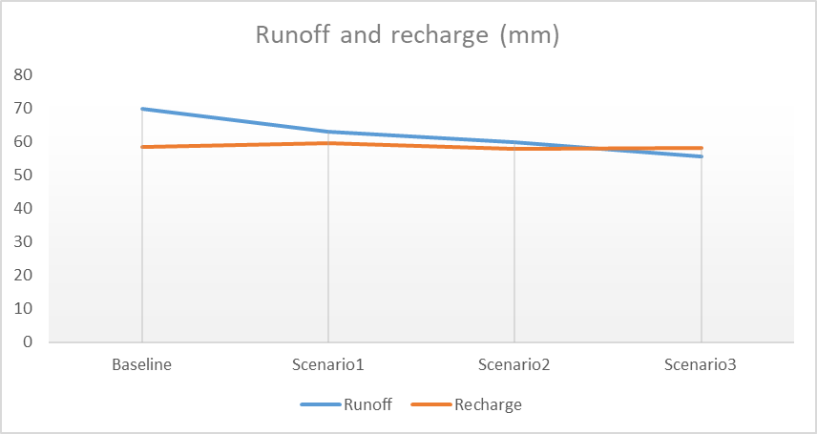

**Figure 7: Impact of interventions on the runoff and recharge in the watershed for mild years**

The impact of increased storage (surface and groundwater) and increased efficiency is visible in increasing yield (shown as % of attainable yield) for different scenarios (Figure 8). For Kharif Tobacco crop, under the increasing intensity of interventions (providing the rainfed area with supplemental irrigation), yield (% of attainable yield) of crop increases from ~85 % in baseline scenario to ~ 94 % in scenario 3. Similarly, with mulching, Bengal gram also shows a slight improvement from 83 % in the baseline scenario to 88 % in scenario 3. On the contrary, Chilly in scenario 1 shows a decrease and thereafter increasing trend. Compared to the baseline scenario, scenario 3 for chilly shows no change (CWR met of ~ 86 %). This is as in the baseline scenario as chilly was the only irrigated crop, all irrigation storage was used for Chilly crop. With the development of supplemental irrigation for Tobacco, a good part is diverted for Tobacco irrigation. Though results show no increase for chilly, but drip irrigation can maintain the yield at the same level despite lower irrigation water available for irrigation and yield remains high.

One additional potential strategy could be to develop more supply interventions as there is available water for capture and recharge. This will increase the irrigation water availability for chilly. Though, the current yield is high (> 85 %) and can be considered drought proofed.

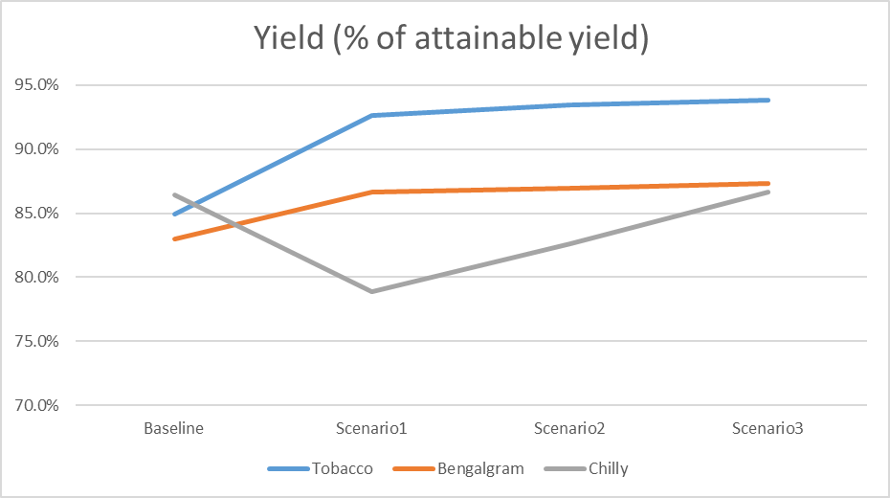

**Figure 8: Wheat yield (% of attainable yield) under different scenarios for mild years**

**Figure 9** shows the impact of interventions on drought proofing quadrant. Increased efficiency while keeping the same CWR met is visible for chilly with it moving further towards the right on the x-axis in quadrant 1 (desirable quadrant). For Tobacco and pulse, movement is on the y-axis with higher CWR met.

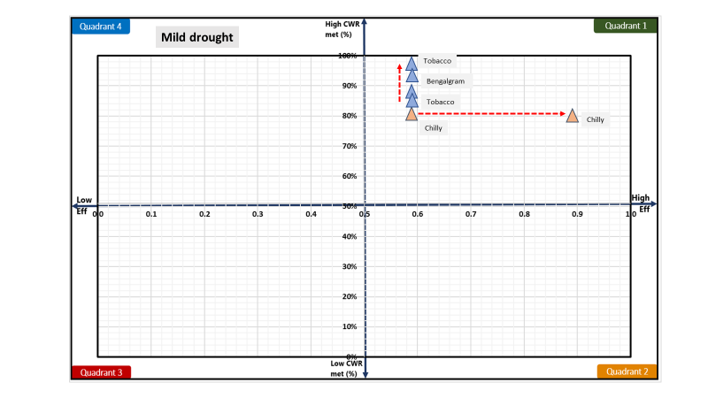

**Figure 9: Impact of interventions visualised on drought proofing quadrant**

**Figure 10** shows the overall watershed drought proofing result for mild years. Percent drought proofing represents total crop production of the watershed as a percent of total potential crop production (i.e. production without any water stress) under different scenarios. The plot shows that drought proofing is achieved to an extent in scenario 3 where drought proofing is almost 90 % as compared to 83 % in the baseline scenario. This means that under mild drought if scenario 3 is planned, 90 % of potential production can still be achieved despite the drought.

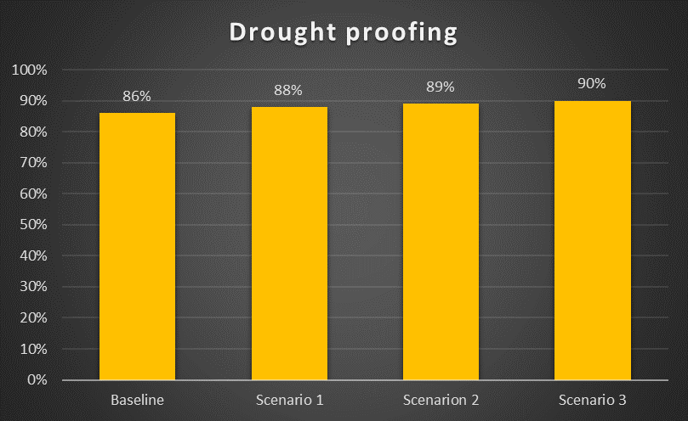

**Figure 10: Overall watershed drought proofing percentage under different scenarios for mild years**

## **Interventions impact on moderate drought**

**Figure 11** shows the impact of interventions on the runoff and recharge in the watershed for moderate drought years. With increasing intensity of interventions, runoff is gradually reduced, and recharge is gradually increased. Compared to the baseline scenario with no intervention, runoff is reduced by 37 % (absolute decrease of 15 mm), and recharge is increased by 3% (an absolute increase of 1.4 mm) in scenario 3. Results show that after scenario 3 there is little available runoff and hardly any runoff leaves the catchment. This reflects the limit of supply-side interventions for moderate drought years.

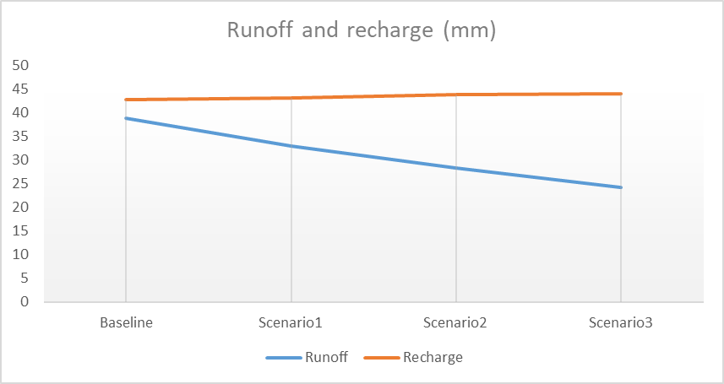

**Figure 11: Impact of interventions on the runoff and recharge in the watershed under different scenarios for moderate years**

The impact of increased storage (surface and groundwater) and increased efficiency is visible in increasing yield (shown as % of attainable yield) for different scenarios (Figure 8). For Kharif Tobacco crop, under the increasing intensity of interventions (providing the rainfed area with supplemental irrigation), yield (% of attainable yield) of crop increases from ~76 % in baseline scenario to ~ 92 % in scenario 3. Similarly, with mulching, Bengal gram also shows slight improvement from 79 % in the baseline scenario to 84 % in scenario 3. On the contrary, Chilly in scenario 1 shows a decrease and thereafter increasing trend. Compared to baseline scenario, scenario 3 for chilly shows only a slight increase (CWR met of ~ 84 %) after an initial drop in scenario 1. This is as in the baseline scenario as chilly was the only irrigated crop, all irrigation storage was used for Chilly crop. With the development of supplemental irrigation for Tobacco, a good part is diverted for Tobacco irrigation. Thus, though chilly shows no increase but drip irrigation can maintain the yield at the same level despite lower irrigation water available for irrigation and yield remains high.

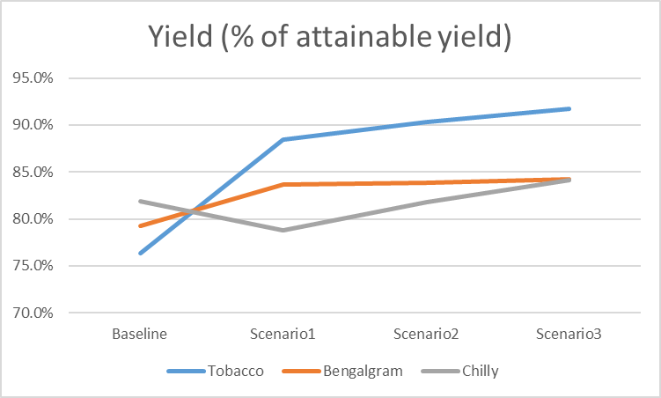

**Figure 12: Wheat yield (% of attainable yield) under different scenarios for moderate years**

**Figure 13** shows the impact of interventions on drought-proofing quadrant. Increased efficiency while keeping slightly increasing CWR met is visible for chilly with it moving further towards the right on the x-axis in quadrant 1 (desirable quadrant). For Tobacco and pulse, movement is on the y-axis with higher CWR met.

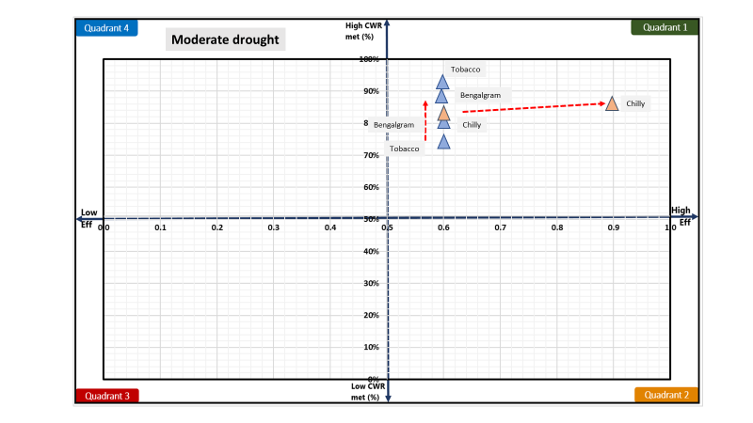

**Figure 13: Impact of interventions visualised on drought proofing quadrant**

**Figure 14** shows the overall watershed drought proofing result for mild years. Percent drought proofing represents total crop production of the watershed as a percent of total potential crop production (i.e. production without any water stress) under different scenarios. The plot shows that drought proofing is achieved to an extent in scenario 3 where drought proofing is almost 88 % as compared to 81 % in the baseline scenario. This means that under moderate drought, if scenario 3 is planned, 88 % of potential production can still be achieved despite the drought.

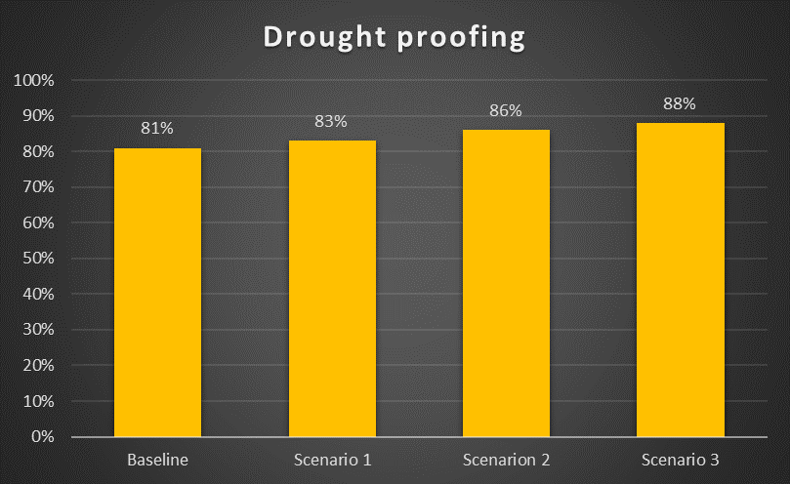

**Figure 14: Overall watershed drought proofing percentage under different scenarios for moderate years**

# **Cost and benefit analysis**

Planned interventions under scenarios entail significant investments for capital infrastructure and maintenance. Cost and benefit analysis is carried out accounting for the net cost and benefits over a horizon of 20 years with an interest rate of 7 %. For more details on how this is calculated, see the [technical manual](https://drive.google.com/drive/u/1/folders/1Yi0Qt4JraRVXNljxe3DB_TAdu5VM8bhg) to see how this is calculated. Very briefly, cost and benefits are analyzed assuming if we had invested in these investments 20 years ago, what would have been the overall cost and benefits considering the last 20 years of rainfall. The last 20 years of observed rainfall is taken as a proxy for future weather.

The result shows that to an extent cost and benefits gradually increase with the intensity of interventions. However, for all scenarios, the benefit cost ration (BCR) is near 2 showing benefits over 20 years will return 2 times the invested amount. High BCR shows for all scenarios indicate that though best drought proofing results can only be achieved with scenario 3 but incremental benefits for all other scenarios are also beneficial. This provides the rationale for staging investment and planning over the project duration aiming to reach scenario 3.

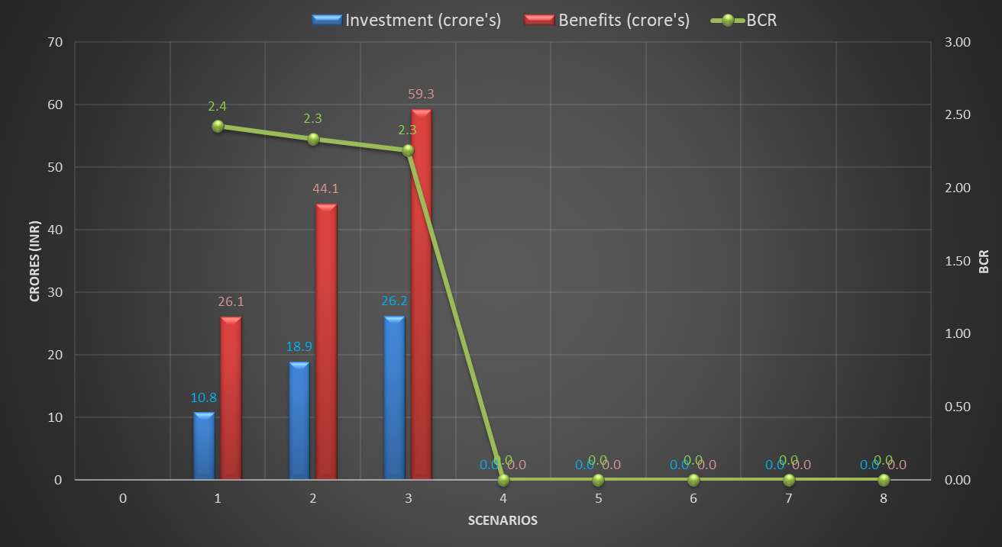

**Figure 15: Cost – benefit analysis**

# **Conclusion and recommendation**

Cherukuru watershed faces frequent mild and moderate drought. Of the last 3 years, 2 have been severe and 1 moderate drought year. Analysis of water balance and deficit shows that drought years significantly impact rainfed crops relying on rainfall and limits the irrigation water availability for irrigated crops. To mitigate the impact of drought, drought proofing measures combining supply and demand interventions are planned. Simulation shows that supply (farm pond, check dams) and demand (micro-irrigation) can mitigate the impact of drought completely to an extent. In addition, providing supplemental irrigation to rainfed Tobacco is critical for achieving drought proofing. Cost and benefit analysis show that all scenarios have BCR ~ 2, showing the incremental benefits under scenarios are more than the investments. Developed scenarios and results provide the rationale for staging investment and planning over the project duration.

**References**

CGWB, 2013. Groundwater information Prakasam district, Andhra Pradesh. Ministry of Water Resources Central Ground Water, Government of India.

Sönmez, F.Kemal., Kömüscü, A.Ü., Erkan, A., Turgu, E., 2005. An Analysis of Spatial and Temporal Dimension of Drought Vulnerability in Turkey Using the Standardized Precipitation Index. Natural Hazards 35, 243–264. <https://doi.org/10.1007/s11069-004-5704-7>

Steduto P, Hsiao TC, Fereres E, Raes D. 2012. Crop Yield Response toWater. Food and Agriculture Organization of the United Nations: Rome, Italy.

World Bank, 2019. Assessing Drought Hazard and Risk: Principles and Implementation Guidance. Washington, DC: World Bank. Link: <https://www.droughtmanagement.info/literature/WBG_Assessing_drought_hazard_and_risk.pdf>

# **Appendix A: Input data**

Table 1A: Land use details

|  |  |  |
| --- | --- | --- |
| **S.no** | **Description** | **Area (ha)** |
| **Total Agri catchment Area (ha)** | | 6727 |
| 1 | Agriculture Area (Net cultivated sown area) | 4708 |
| 2 | Fallow | 350 |
| 3 | Built-up / Settlements | 468 |
| 4 | Waterbodies | 350 |
| 5 | Pasture | 425 |
| 6 | Forest | 426 |

**Table 1B: Soil Data**

|  |  |  |  |  |
| --- | --- | --- | --- | --- |
| **S.no** | **Soil Type** | **Soil Depth (m)** | **Soil Distribution**  **(%)** | **Ground Water Yield of area (l/s)** |
|  | Clayey loam | 0.35 | 25% | 2.8 litre/per second |
|  | Clay soil | 0.40 | 60% | 2.6 litre/per second |
|  | Sandy loam (red soil) | 0.30 | 15% | 3.3 litre/per second |

Table 1C: Cropping pattern details

|  |  |  |  |  |  |  |  |
| --- | --- | --- | --- | --- | --- | --- | --- |
| **Area** | **Crop name** | **Area Sown (ha)** | **Irrigation (ha)** | | **Crop Duration (days)** | **Crop Sowing Date** | |
| **Irrigated** | **Rainfed** | **Month** | **Week** |
| Kharif | | | | | | | |
| Area 1 | Tobacco | 1888 | 1000 | 888 | 130 | Sept | 1 |
| Area 2 | Chilly | 720 | 720 | - | 210 | August | 1 |
| Rabi | | | | | | | |
| Area 3 | Bengal gram | 1150 | - | 1150 | 60 | Nov | 2 |

Table 1D: Crop details

|  |  |  |
| --- | --- | --- |
| **Crop name** | **Crop yield (tonne/ha)** | **Price (Rs/Tonne)** |
| Tobacco | 1.7 | 180000 |
| Chilly | 6.5 | 120000 |
| Bengal gram | 1.5 | 45000 |

Table 1E: irrigation & domestic details

|  |  |  |  |  |
| --- | --- | --- | --- | --- |
| **Irrigation Source** | **Area (%)** | **Irrigation efficiency** | **Residual storage** | **Non-Renewable storage** |
| Irrigation | | | | |
| **Groundwater** | 30 | 0.5 | 0 | No |
| **Surface water** | 70 | 0.5 | 0 |  |
| Domestic | | | | |
| **Population** | Daily water usage (LPD) | GW dependent | SW dependent |  |
| 11200 | 129 | 60 | 40 |  |